**Northeastern University**

CS 5100 Foundations of AI

**Midterm Exam 8/17/20** [100 points]

This is an open book exam. Pen and paper preferred. Scan answers to PDF. Duration: 24 Hours

Answer all questions, with brief but complete explanations. K*eep your answers concise and to the point. Please write legibly. Write your name all pages. Answer on separate papers.*

1. The monkey-and-bananas problem is faced by a monkey in a laboratory with some bananas hanging out of reach from the ceiling. A box is available that will enable the monkey to reach the bananas if he climbs on it. Initially, the monkey is at A, the bananas at B, and the box at C. The monkey and box have height Low, but if the monkey climbs onto the box he will have height High, the same as the bananas. The actions available to the monkey include Go from one place to another, Push an object from one place to another, ClimbUp onto or ClimbDown from an object, and Grasp or Ungrasp an object. The result of a Grasp is that the monkey holds the object if the monkey and object are in the same place at the same height.
2. In this problem’s context, explain what is meant by Classical Planning, and its 5 key elements (Action Schema, Precondition, Effect etc.) [5 points]
3. Refer to Figure 10.1 (A PDDL description of an air cargo transportation planning problem) on pg. 369 of Norvig AI textbook. Develop a similar table for the above problem. [10 points]
4. Ch. 16 **Making Simple Decisions**

Consider a student who has the choice to buy or not buy a textbook for a course. We’ll  
model this as a decision problem with one Boolean decision node, B, indicating whether the  
agent chooses to buy the book, and two Boolean chance nodes, M, indicating whether the  
student has mastered the material in the book, and P, indicating whether the student passes  
the course. Of course, there is also a utility node, U. A certain student, Sam, has an additive  
utility function: 0 for not buying the book and -$100 for buying it; and $2000 for passing the  
course and 0 for not passing. Sam’s conditional probability estimates are as follows:

|  |  |
| --- | --- |
| P(p|b, m) = 0.9  P(p|b, ¬m) = 0.5 | P(m|b) = 0.9 P(m|¬b) = 0.7 |

P(p|¬b, m) = 0.8  
P(p|¬b, ¬m) = 0.3  
You might think that P would be independent of B given M, But this course has an openbook final—so having the book helps.  
**a**. Draw the decision network for this problem. [5 points]  
**b**. Compute the expected utility of buying the book and of not buying it. [10 points]

**3.** Given in Table 1 below is Data on customers who purchased a PC at a computer store, showing age group, income, education and whether they purchased a PC earlier.

(A) What is **Naïve Bayes** algorithm? What is it used for in Machine Learning? [3 Points]

(B) For the same PC purchase dataset given in Table 1 below, develop a Naïve Bayes Classification method, and use the same to classify the new example given below. [7 Points]

|  |  |  |  |  |  |  |
| --- | --- | --- | --- | --- | --- | --- |
| Senior | High | High School | Yes |  |  | ? |

Clearly show all of your calculations, step by step.

Table 1. Data on customers who purchased a PC

|  |  |  |  |  |
| --- | --- | --- | --- | --- |
| **Age** | **Income** | **Education** | **Prior Purchase** | **Buys PC?** |
| Young adult | High | College | Yes | Yes |
| Middle Age | Low | College | No | No |
| Middle Age | High | High School | Yes | No |
| Senior | Low | College | No | No |
| Young adult | Medium | High School | Yes | Yes |
| Senior | High | College | yes | Yes |
| Middle Age | Medium | College | No | No |
| Young adult | Low | High School | No | No |
| Middle Age | Low | College | Yes | Yes |
| Young adult | High | College | No | Yes |
| Senior | Medium | High School | No | No |

1. Given the below neural network for home price prediction: [10 Points]

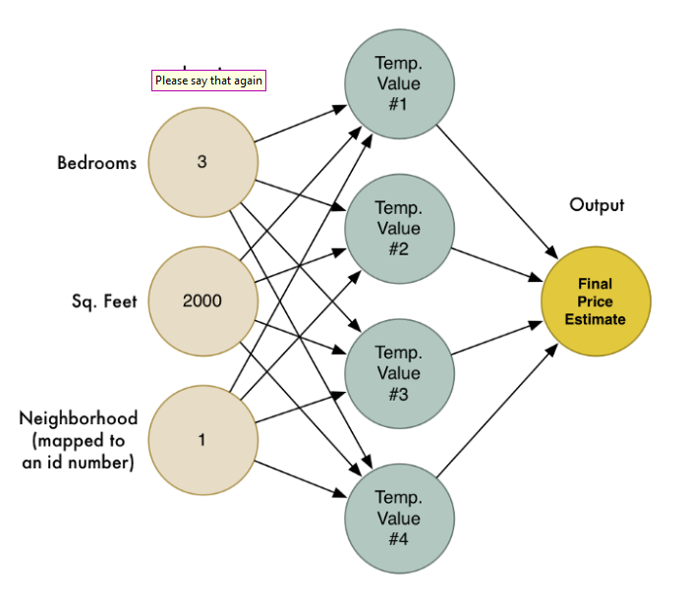

Weights w on ALL of the forward arrows from every neuron is equal to 0.1.

Describe the forward propagation algorithm, and show an example calculation of a final price estimate.

1. **Computer Vision** [20 Points]

Consider the image below: **A couple with a cat**



Develop a series of algorithms (i. e., a design) for face recognition for this object – your algorithm needs to recognize faces of people and animals, provide a count of them and identify the animal.

1. From Chapter 25, use Execice 25.7 as the basis for this question. Our goal is for the robotic arm (Fig 25.32 on page 1017) to start in Position (a) and reach position (c) for Picking an object – say a red Cube. Identify 5 algorihms/methods to accomplish the needed operations to do this: Pperception, Planning to Move and Moving. Describe each of them in suficient detail (1-2 small paragraphs, diagrams to explain). [20 Points]
2. Given the below data set with two classes of data points in a 2D plane. What are support vectors? How do they help with classification problems? Draw the SVM boundaries on the below or similar figure.

Explain how SVM works as a classification algorithm. [10 Points]

